Royal Commission on the Pike River Coal Mine Tragedy
Te Komihana a te Karauna mō te Parekura Ana Waro o te Awa o Pike

Chronology One - New Zealand Mining and Coal Production Profile

Date | Event | Reference /page para
1890 - 2009 | New Zealand coal production by mining method:  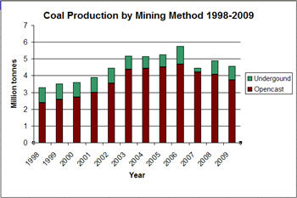  MEDT2, para 35, MED000001.0001/ 10  http://www.nzpam.govt.nz/cms/coal/facts-and-figures/facts-and-figures/#Mining_method  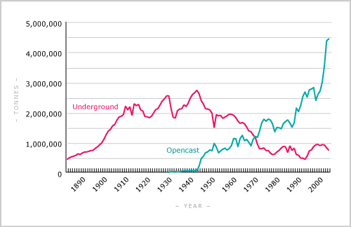  http://www.teara.govt.nz/en/coal-and-coal-mining/6/5
1849 | First recorded coal mine in New Zealand (Saddle Hill, Dunedin) began production. | MED0000010001/8 8
1864 | Mining at Brunner Hill (West Coast) began. | MED0000010001/8 8
1874 | Legislation enacted giving the Governor of New Zealand the power to proclaim mining districts and appoint mining inspectors. | MED0000010001/9 12
1877 | Governor possessed power to issue mining licences. | MED0000010001/9 12
1877 | Boards established to oversee mining operations at district level. | MED0000010001/9 12
1879 | Mines started to be developed on Denniston plateau with creation of a cable railway and branch railway line to Westport. | MED0000010001/9 10
1886 | Mines Department established to oversee mineral and coal mining industries. | MED0000010001/10 13
1896 | The majority of West Coast coal fields were owned by the Union Steam Ship Company. | MED0000010001/9 10
1896 | There were 163 coal mines in New Zealand, of which 20 employed more than 20 men. Denniston employed around 315 workers; Kaitangata employed at least 140; and Huntly employed at least 100. | MED0000010001/9 11
1900 | Coal was the principal source of energy in New Zealand with coal production exceeding 1 million tonnes. | MED0000010001/10 14
1900 | All coal mines were privately owned and operated. | MED0000010001/10 14
1901 | State Coal Mines was established as a government trading enterprise. | MED0000010001/10 14
1910 | Coal production reached 2 million tonnes. | MED0000010001/10 15
1939 | 2% of coal was mined by opencast methods.  Opencast recovers approximately 90% of a coal seam. | www.teara.govt.nz  MED0000010001/11 23
1940 | Coal accounted for half of New Zealand’s energy supply.  Major users were railways, gasworks, industry, domestic users. | MED0000010001/10 16
1945 | 16% of coal was mined by opencast methods. | www.teara.govt.nz
1949 | Over half of New Zealand coal is produced by state owned coal mines. | MED0000010001/10 17
1950 | State Coal Mines is the largest coal producer. | MED0000010001/10 17
1952 | State Coal Mines operated 28 underground mines and 13 open pit mines. | MED0000010001/10 17
1953 | Number of New Zealand mines is 216.  Number of miners is approximately 5000. | MED0000010001/10 18
1960 | 37% of coal is mined by opencast methods. | www.teara.govt.nz
1967 | 120 working coal mines. | MED0000010001/11 19
1973 | Number of New Zealand mines is 78.  Number of miners is approximately 1500. | MED0000010001/10 18
1975 | Government starts a comprehensive coal exploration programme which leads to the discovery, by 1989, of 14 billion tonnes of new coal resources. | MED0000010001/ 11 20
1979 | 69% of coal was mined by opencast methods. | www.teara.govt.nz
1987 | State Coal Mines became Coal Corporation of New Zealand Limited. | MED0000010001/ 11 21
1992 | Number of New Zealand mines is 64. | MED0000010001/ 11 19
1996 | Coal Corporation of New Zealand changed its name to Solid Energy New Zealand Limited. | MED0000010001/ 11 21
2000 | 45 working coal mines. | MED0000010001/11 19
2000 | Coal mining employees in New Zealand number 630. | Statistics New Zealand  http://wdmzpub01.stats.govt.nz/wds/TableViewer/tableView.aspx
2005 | Coal mining employees in New Zealand number 840. | Statistics New Zealand  http://wdmzpub01.stats.govt.nz/wds/TableViewer/tableView.aspx
2009 | 5 underground coal mines (4 in West Coast)  16 opencast mines (13 in South Island) | MED0000010001/ 13 30
2009 | Main coal mining areas were Waikato, West Coast, Canterbury, Otago, and Southland. | MED0000010001/12 29
2009 | Underground mining represented 18% of New Zealand’s total coal production. | MED0000010001/15 34
2010 | Coal mining employees in New Zealand number1030. | Statistics New Zealand  http://wdmzpub01.stats.govt.nz/wds/TableViewer/tableView.aspx

Excludes PRC.

